Fundamental movement skills (FMS) are the movements we use to be active such as running, jumping, leaping and throwing.
Learn how to correctly do each skill and make your own poster.

Gather your materials
- Something you can take photos on (smart phone/ iPad/ tablet/ digital camera)
- Observational posters https://www.islhd.health.nsw.gov.au/posters
OR paper copies of posters given to you by your teacher
- Get Skilled, Get Active YouTube videos
https://www.youtube.com/playlist?list=PLrOa7LNP0maWa6EPlnkvHlk3VsBqhuMZq

Research
- Ask you parent/carer for help to research the movement you are going to do.
- Watch the YouTube clip of your Fundamental Movement Skill OR look at the paper copy of Get Skilled, Get Active Posters.

Practise
- Find a clear, safe space in your home to practise your movement skill.
- Check the ground is flat and there is room to move without touching anything.

Take photos
- Set up your camera or ask an adult or sibling to take photos of you doing your skill.
- Check that your photos clearly show you correctly performing the skill. Watch the video on YouTube or look at the posters to help you do each movement correctly.

Make your poster
- Upload your photos to your computer and insert your photos into the template. Ask your parent/carer if you need help to do this.
- Type your name and school on the template then email or show this to your teacher.

Worksheets and videos
- Skills Worksheet
https://www.islhd.health.nsw.gov.au/sites/default/files/Health_Promotion/Live_Life_Well/Student_Worksheet.docx

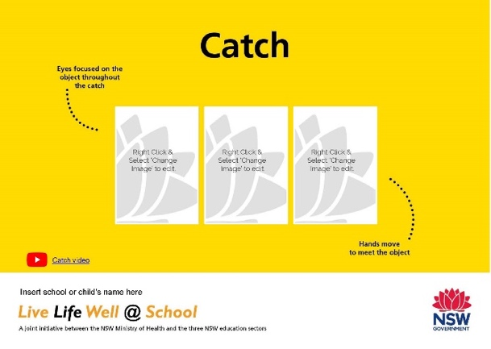

- Get Skilled, Get Active Posters
https://www.islhd.health.nsw.gov.au/posters
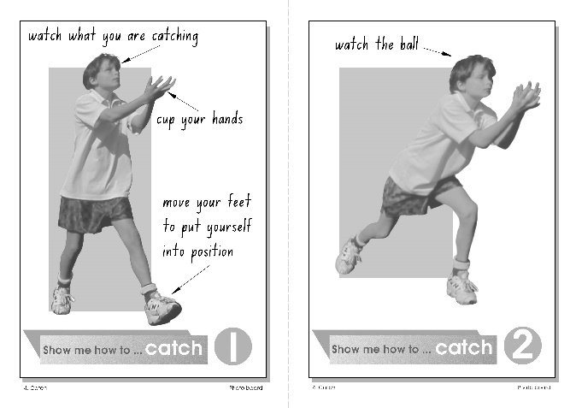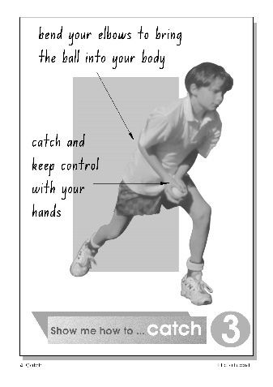

- Get Skilled, Get Active Videos
https://www.youtube.com/playlist?list=PLrOa7LNP0maWa6EPlnkvHlk3VsBqhuMZq

