How to find coordinates
Use sites
https://www.gps-coordinates.net/
http://www.whatsmygps.com/
or similar

Instructions for Google and Bing maps
https://www.online-tech-tips.com/computer-tips/find-longitude-latitude/

Google Maps
I use Google Maps mostly for my mapping needs because I think they have the best data and the most features. To get GPS coordinates using Google Maps is really easy. There are two ways you can go about it.
Firstly, go to maps.google.com and type in the address or location you are interested in. Once it has loaded, you can just look in the address bar and you’ll see the coordinates are contained within the URL itself.
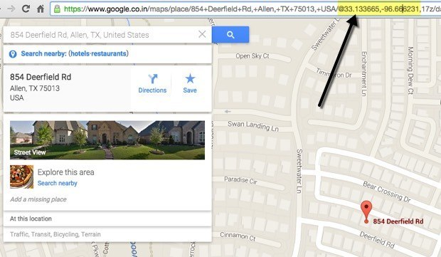
What if the location you are trying to get coordinates for doesn’t have an address that shows up in Google Maps? That’s not a problem either. In that case, you can just right-click anywhere on the screen and choose What’s here?
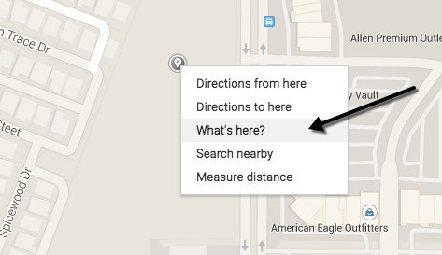
This will bring up a small box that it located directly below the search box. At the bottom of that box, you will see the decimal coordinates listed.
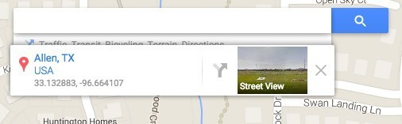

Bing Maps
I also mention Bing Maps because they do show the coordinates front and center, which is nice. Just search for any location and you’ll see the coordinates displayed on the left hand side.
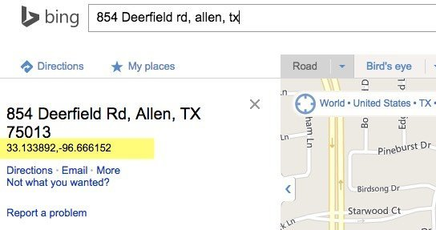
For a location without an address, you can simply right-click anywhere on the map and it displays the coordinates automatically. So Bing is definitely easier to use when looking for GPS coordinates.
