Quick Reference Guide – ISLHD Internet
Content Management System
Create or Edit Basic Page
Objective: User can create content using Basic Page content type.
Action | Description
Pre-requisites | User account on the server with appropriate permissions
Notes and Precautions | We recommend you use either Chrome or IE11 for editing in Drupal.  If copying text from a word document make sure copy to the notepad first to remove formatting.
Naming Convention and other important things to consider | Make sure you are familiar with the naming convention for the site.  Make sure you know where it should live on the menu. Failing to make it part of the menu means the page will not show in the navigation.
Content | According to recognised web experts and organisations there is a recommendation of having around 200 to 300 words per web page. This is a guideline only.  If the page does require more content and if the content contributes to the quality of the page then it may be as long as deemed appropriate: which means the page has to scroll. For a good user experience you should avoid the user having to click excessive numbers of links increasing unnecessary page loads and load time.  If your pages are lacking content try combining them into 1 page and reduce the number of pages.  Gov.au Content Guide - A guide to help Australian Government teams design simple, clear and fast content.  ISLHD Patient Information Portal – ISLHD approved plain English and translated consumer information is found here. You will also find all the tools you need to develop plain English consumer resources.
Create Basic Page
Navigate to the content list page, use content filters to check if the page exists. Start typing title or use Basic page content type to filter. (need to press the Filter button to see results)
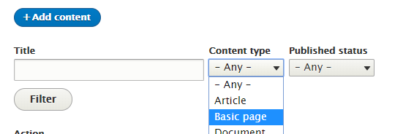
Click Add Content button, select Basic Page and click to create a page.
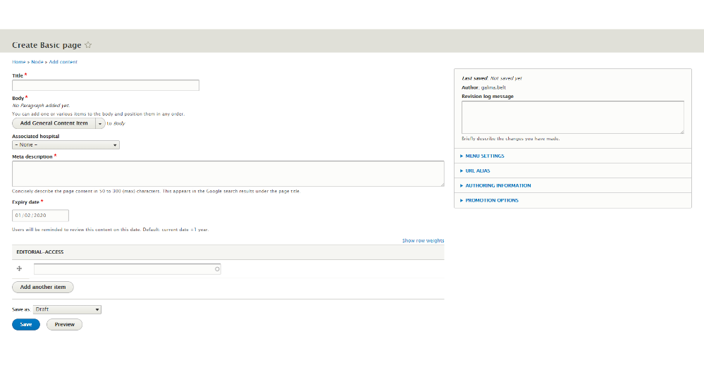

Main sections and mandatory fields
Title | Title - this will appear at the top of the page, URL and when added to the menu, in the navigation. Make sure each page has a unique, descriptive title - ideally between 50-60 characters.
Body
Body - this is where you can add and format your content. There are few different ways you can do that. The order is up to you and it could be changed later.
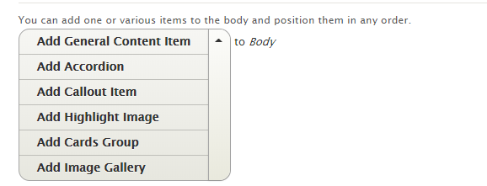
General Content Item – use if only need generic page content, it will create WYSIWYG editor window ( WYSIWYG is an acronym for What You See Is What You Get).
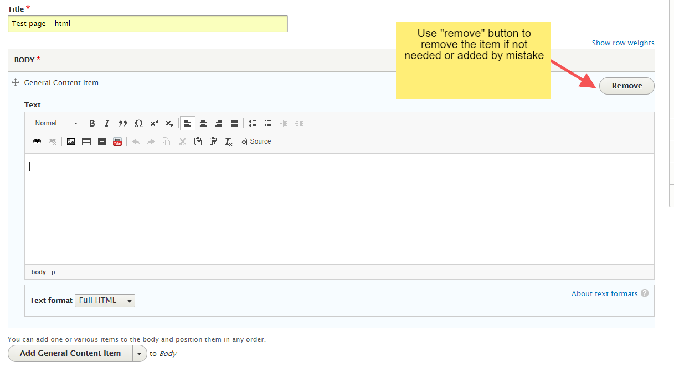

Accordion item – use for collapsible content: accordions are useful when you want to toggle between hiding and showing large amount of content, eg Frequently Asked Questions
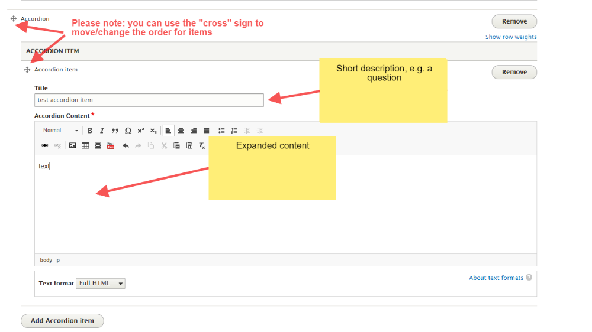
Callout item
Highlight Image
Cards group – use as a way of linking to more information – can be used with or without pictures

Image Gallery
Associated hospital | Associated hospital – if this page has information about a hospital or a service which belongs to a hospital, please select a hospital from the drop down. Otherwise leave as -None-  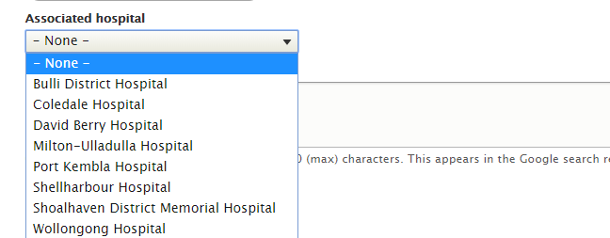
Meta description | Meta description - this will be the description of the URL when users find the page on Google and other search engines - it provides the user with an overview of what to expect on the page. Each page needs a unique and relevant description.
Revisions logs – make it a habit to make a short note here of what is updated every time you make updates, makes it easier to see what was updated
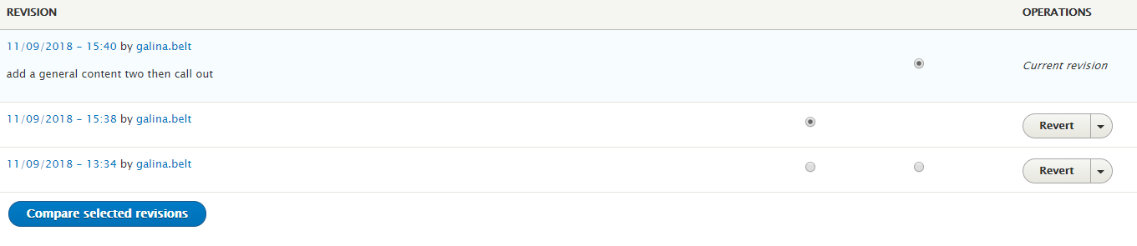
However you can compare the revisions if you click on the Compare selected revisions button

Menu settings | Menu settings – in Menu Settings, check box Provide a menu link, make sure the Menu Link title is correct, select the Parent item from the drop down list  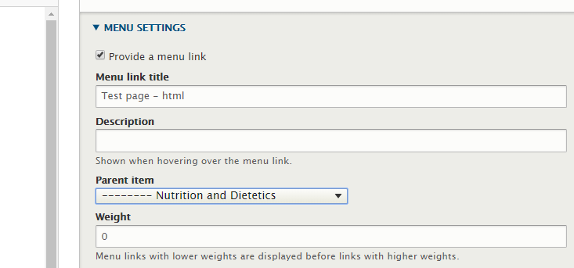
Expiry date | Check you're happy with the Expiry date or change it if needed: e.g. if a page needs a review in three months
Editorial-Access | Editorial Access – IMPORTANT, please start typing and select your group name otherwise you will not be able to access the page.
Saving the page and the workflow | Scroll to the bottom of the page and save using the Save as selecting Draft option at first.  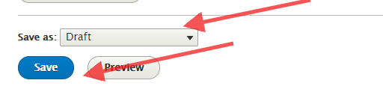  When the page is ready – Save as selecting Content Owner Review option.  When a page is approved – Save as selecting Published option from the drop down
Edit an existing page in Drupal | If you have successfully logged in, you should see a edit tab at the top or little icon on right hand corner of the page  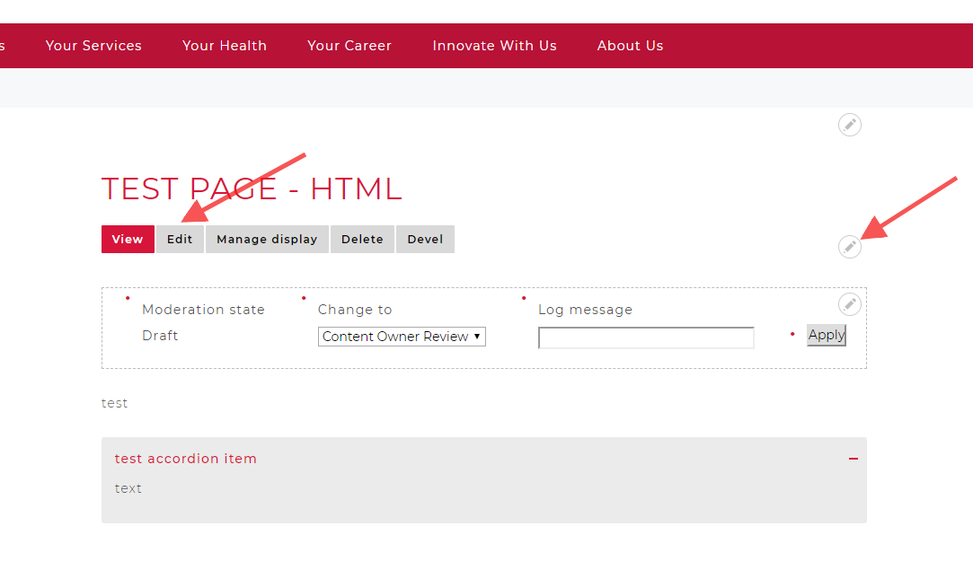
Alternatevily navigate to the content list page, search for the page using filters
Click Edit button on the right hand side
Need help? | If your application is not working properly, you can submit an Incident Report through State Wide Service Desk at 1300 28 55 33 and specify it as ISLHD Internet issue  To learn more how to use the tool, contact <Web Team >
Document information
Owner
First published
Current version
Version change log

