Quick Reference Guide – ISLHD Internet
Content Management System
Create or Edit Profile
User can create content using Profile content type.
Action | Description
Pre-requisites | User account on the server with appropriate permissions
Notes and Precautions | We recommend you use either Chrome or IE11 for editing in Drupal
Naming Convention and other important things to consider | Staff profiles are entered prior the assigning a specialist to Service or Clinic. Make sure you have all the information about a person or a team ready.
Create Profile
Navigate to the content list page, use Profile content type filter to check if the page exists
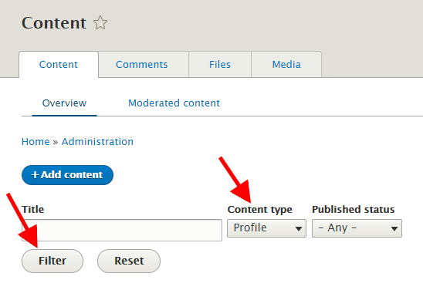
Click Add Content button or select add content from the drop down menu. Select Profile
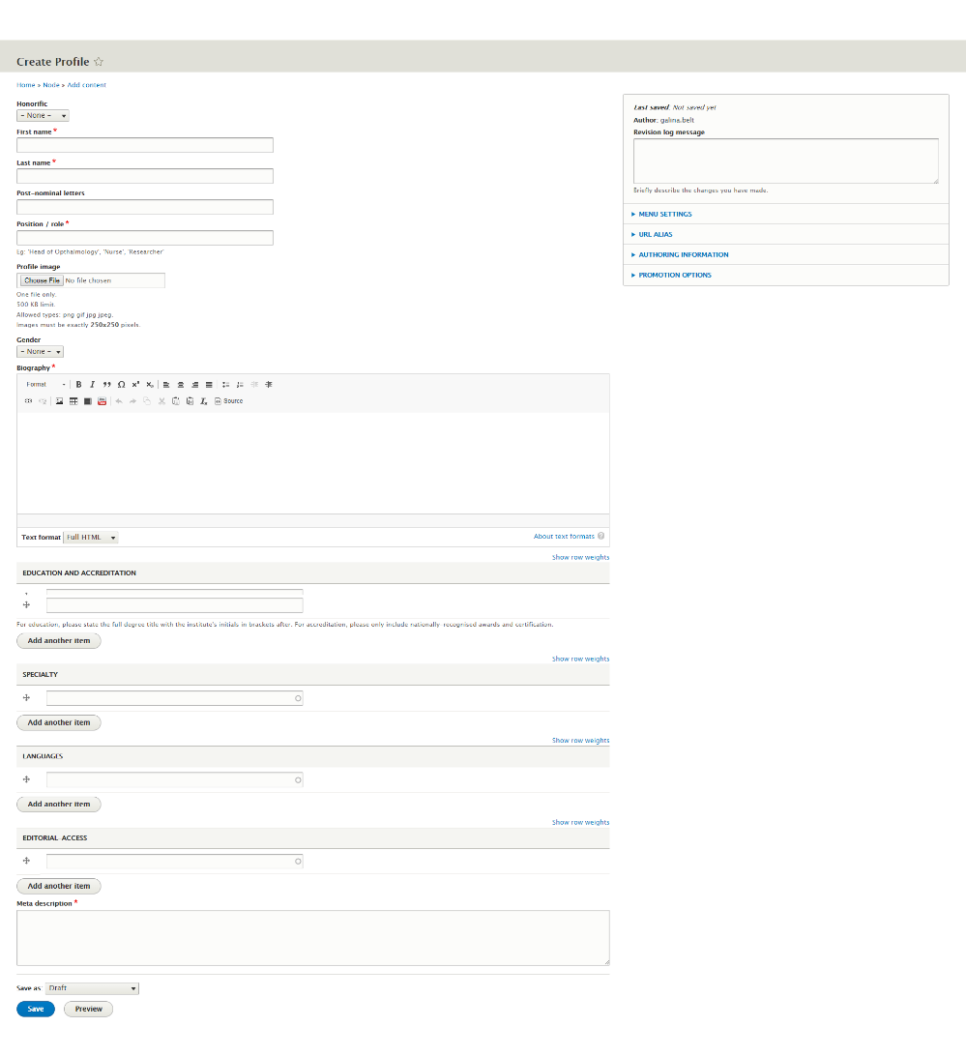
Main sections and mandatory fields | Honorific – select an appropriate or leave none for teams  First name – make sure the correct spelling  Last name – make sure the correct spelling  Team name ?  Post-nominal letters: MB BCh, FRCPI, FRACP, PhD  Position / role: enter the official name Eg: 'Head of Opthalmology', 'Nurse', 'Researcher'  Profile image: please make sure the consent is given and appropriate process followed. Note: please rename the image to make sure the file name for it is FirstName-LastName.jpg or FirstName-LastName.png  Gender:  Biography: enter and use the standard editor butons to format
EDUCATION AND ACCREDITATION: For education, please enter the full degree title with the institute's initials in brackets after. For accreditation, please only include nationally-recognised awards and certification. You can enter as many as you like – press Add another item button to add more. Drug plus sign next to the item to reorder.
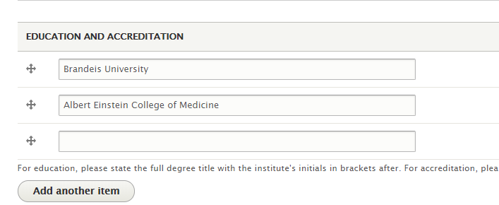
 | SPECIALTY: Please start typing and select the needed speciality. You can also enter one, making sure only include nationally-recognised specialities. You can add as many as you want.
LANGUAGES: Please start typing and select the needed. You can add as many as you want from the list of available languages. Contact web team if you tried to add and the language is not there (in this case you would not be able to save a profile and the item will be red, see the below scrennshot)
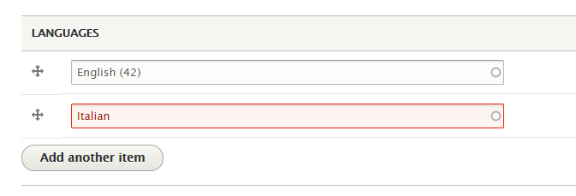
 | Revisions logs - Briefly describe the changes you have made.
 | Menu settings: Not applicable for this content type
Saving the page, workflow | Scroll to the bottom of the page and press Save button.  Make sure you save a draft first.
Edit an existing profile in Drupal | If you have successfully logged in, you should see a edit tab at the top or little icon on right hand corner of the page  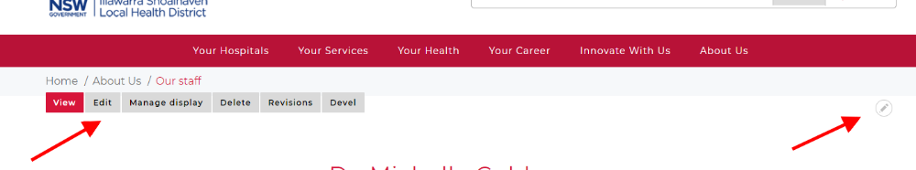
Alternatevily navigate to the content list page, search for the profile.
Click edit option on the right
Need help? | If your application is not working properly, you can submit an Incident Report through State Wide Service Desk at 1300 28 55 33 and specify it as ISLHD Internet issue  To learn more how to use the tool, contact <Web Team >
Document information
Owner
First published
Current version
Version change log

