Quick Reference Guide – ISLHD Internet
Content Management System
Create or Edit Service Page
User can create content using Service Page content type.
Action | Description
Pre-requisites | User account on the server with appropriate permissions
Notes and Precautions | We recommend you use either Chrome or IE11 for editing in Drupal
Naming Convention and other important things to consider | Make sure you are familiar with the naming convention for the site  Make sure you know that the category the service belongs to has been set up. Tag service with the relevant Health Journey item.
Create Service Page
Navigate to the content list page, use content filters to check if the page exists.
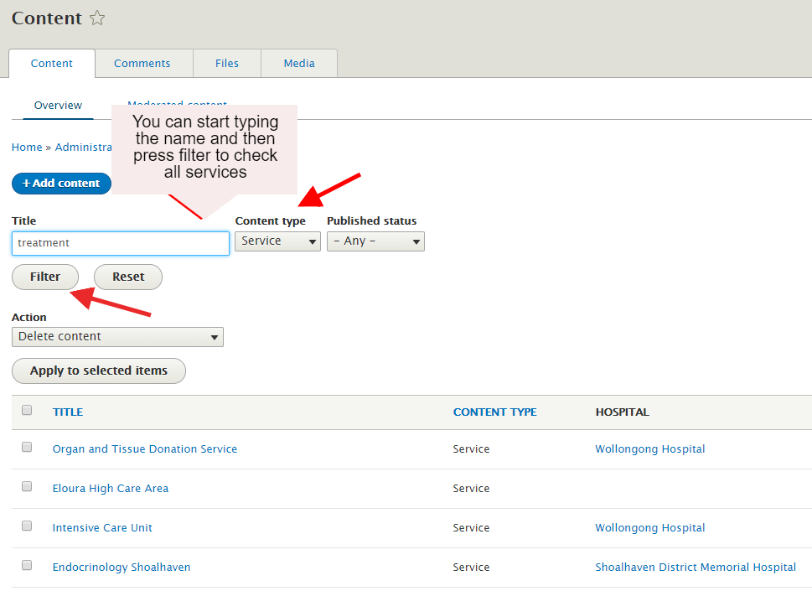
Click Add Content button
Select Service, fill in the fields of the following form to create a service page.
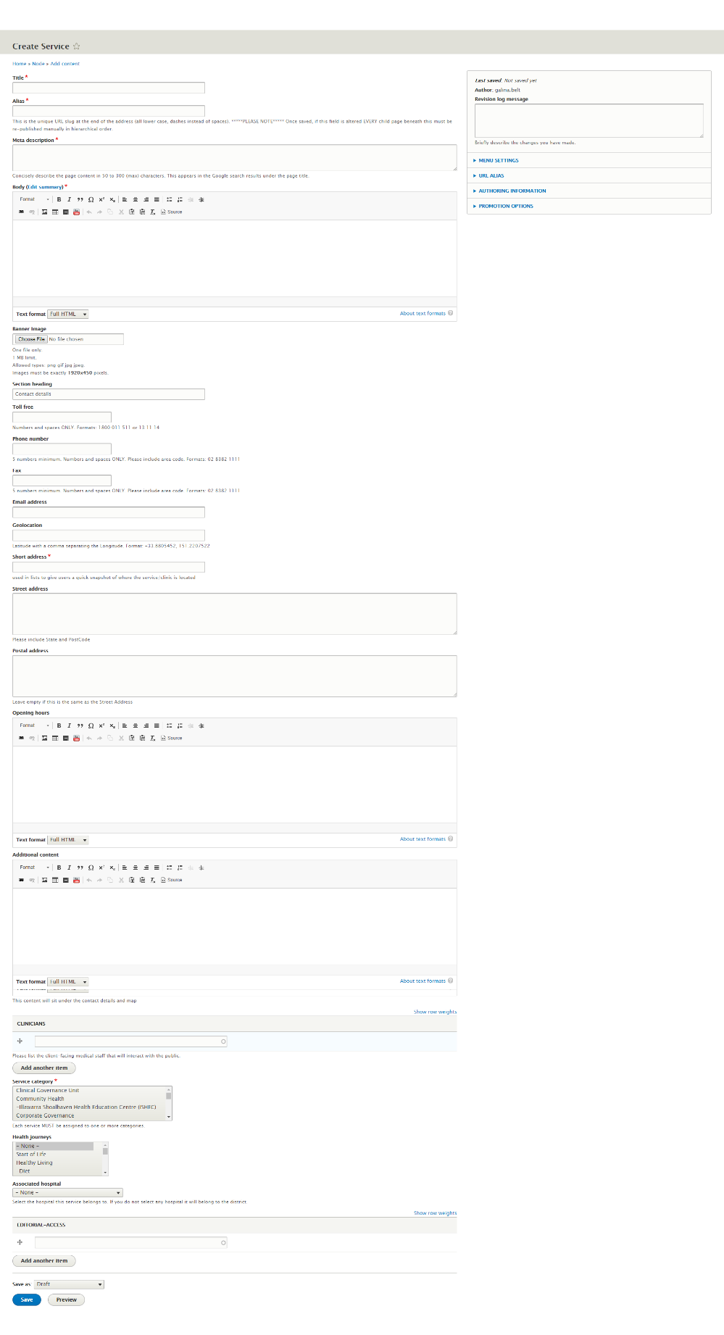

Main sections and mandatory fields | Title - this will appear at the top of the page, URL and when added to the menu in the navigation. Make sure each page has a unique, descriptive title - ideally between 50-60 characters.
Alias – short URL for the service e. g. …./t-s-d1 instead of …..TEST SERVICE DISTRICT 1. Please note all the pages which belong to this service would appear under this URL – e.g.
/t-s-d1/basic-page-district-1
 | Meta description - this will be the description of the URL when users find the page on Google and other search engines - it provides the user with an overview of what to expect on the page. Each page needs a unique and relevant description.
Body: the information you want to see on the first page as an Overview. Use the standard editor buttons to format as needed.
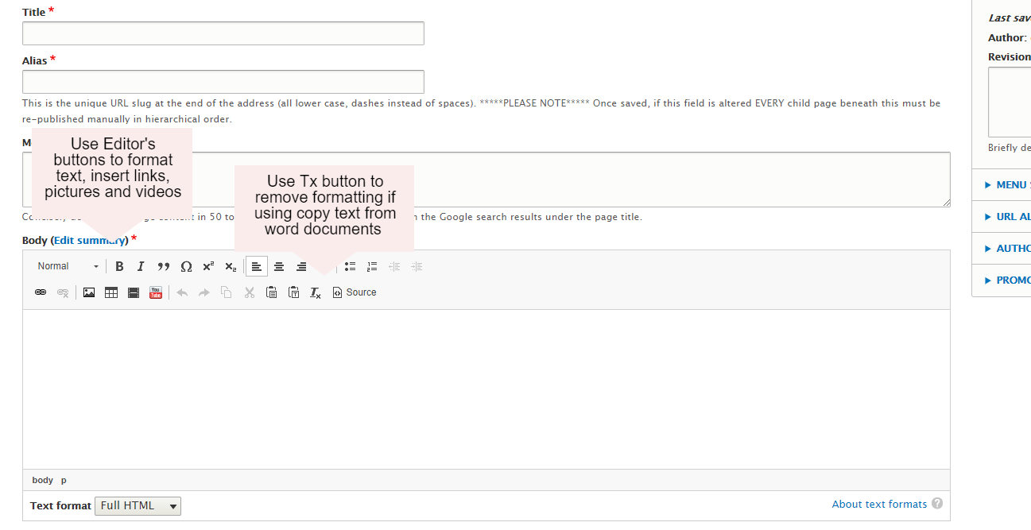
Note: Please use Heading 3 for all you headings on this page: Heading 1 used as a title, and Heading 2 used for “Overview” and “Contact Details”
 | Banner Image – Big hero image displayed on the top of the page, please contact Corporate Communications or ICT web team to discuss.
Sections heading | All the information after this will appear on a different page – eg Contact Details (use the default or can change to similar heading)
Toll free – leave empty if N/A. Numbers and spaces ONLY.
Formats: 1800 011 511 or 13 11 14
Phone number Numbers and spaces ONLY. Please include area code. Formats: 02 8382 1111
Fax Numbers and spaces ONLY. Please include area code. Formats: 02 8382 1111
Email address –
Geolocation Latitude with a comma separating the Longitude. Format: -33.8805452, 151.2207522 . To get this information from Google or Bing maps see Apendix 1 – please ask Web Team for help if not sure.
Short address used in lists to give users a quick snapshot of where the service/clinic is located
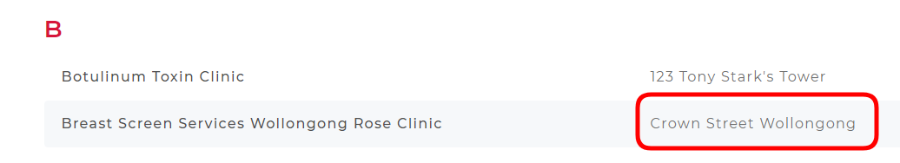
Street address Please include State and PostCode
Postal address Leave empty if this is the same as the Street Address
Opening hours for consistency please use a table to add? :
Day(s) of the week | Opening hours

Clinicians – start typing to add a clinician or a team or a staff member. The information about added clinicians/teams will appear on a separate page (Staff)
Note: all profiles should be created separately prior to be added here.
Categories – at least one must be selected for all services. Can slect more than one category. Please make sure you ONLY selecting “subcategories” – the ones with “- “ next to them
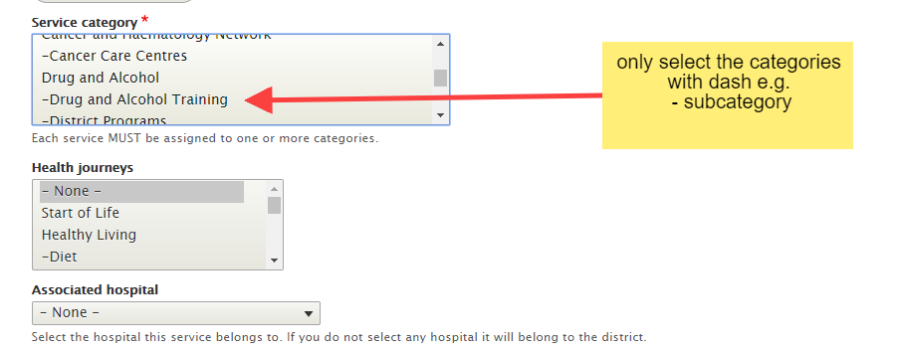
If you cannot find the correct one please contact the ICT web team.
 | Health journeys – this will make the service listed under one of the Health Journey pages/tags.
 | Associated hospital – leave blank if it’s a district service, otherwise select a relevant hospital
 | Editorial Access – IMPORTANT, please start typing and select your group name otherwise you will not be able to access the page.
 | Revision log message – it’s a good practice to leave a brief note of changes made
Menu settings – Click on the Provide a menu link check box. A Menu link title should appear automatically but you can change it as required.
Select the Parent item from a relevant place on Main navigation drop down, e.g scroll down to Coledale Hospital, then select Services and Clinics
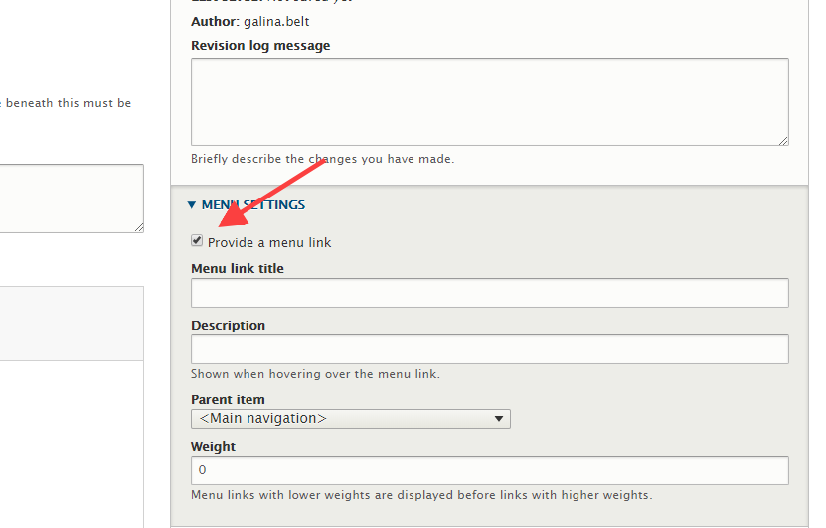
Note: NEVER select the <Main navigation> as your parent item !!!
Saving the page, workflow and revision date | Scroll to the bottom of the page and press Save  Check you're happy with the Revision date or change it
Edit an existing page in Drupal | If you have successfully logged in, you should see an edit tab at the top part of the page and a little icon on right hand corner of the page: click on the Edit tab to edit.  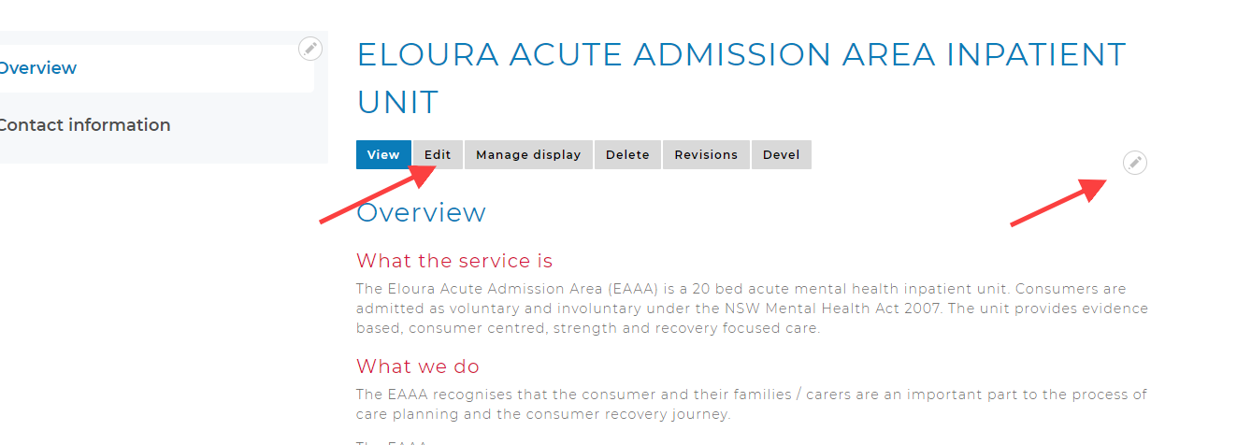
Alternatevily you can also find the page on the Content list using Filter: navigate to the content list page, search for the page using filters
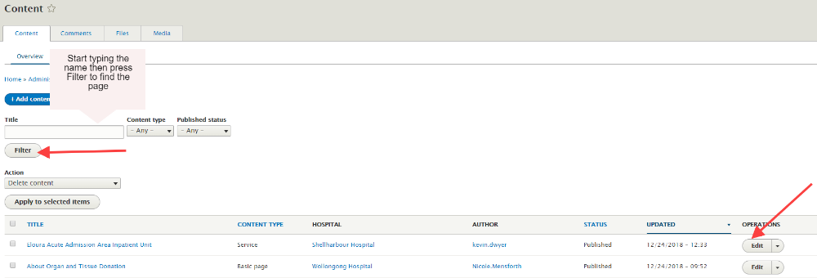
Click Edit from the drop down on the right hand side.
Need help? | If your application is not working properly, you can submit an Incident Report through State Wide Service Desk at 1300 28 55 33 and specify it as ISLHD Internet issue  To learn more how to use the tool, contact <Web Team >
Document information
Owner
First published
Current version
Version change log

