Quick Reference Guide – ISLHD Internet
Content Management System
WYSIWYG editor window and file management
Objective: User can use edit the text using the editor and IMCE.
Action | Description
Pre-requisites | User account on the server with appropriate permissions
Notes and Precautions | User has used the single-use link in the system generated welcome email and set a password for their account.  We recommend you use either Chrome or IE11 for editing in Drupal
WYSIWYG editor | WYSIWYG editor window ( WYSIWYG is an acronym for What You See Is What You Get) is used for different bits of content editing, such as Body for Service content type, General Content item text, or Accordion Content of a Basic page etc  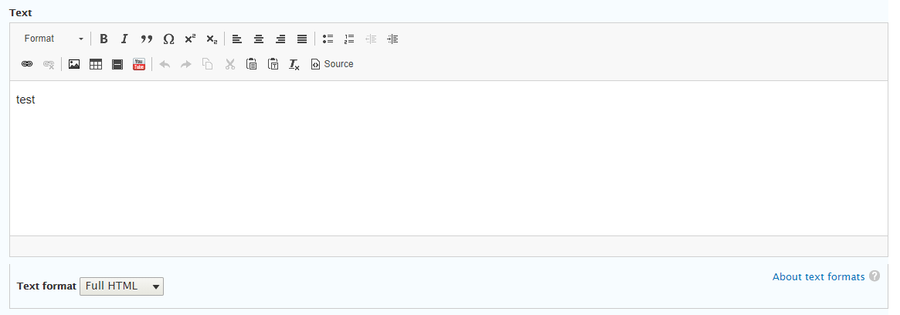
Header and Text Formatting | When you enter text in to the content editor you need to format things like headings using the native formatter dropdown in the editor window.  In the tool bar (highlighted) are options for formatting and some document, image and video upload features.  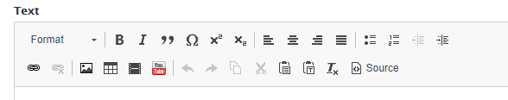  For example if you have a level 2 heading select the text and format it using the appropriate setting in the drop down menu shown below.  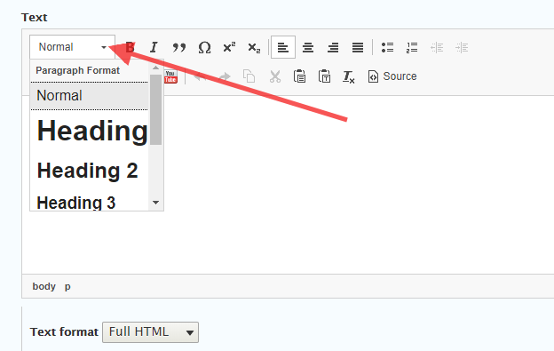  Note:  - Level 1 heading is reserved for a title of a page.  - Service content type uses headings 2 for Overview and Contact Us - for Service body text use level 3 headings.  If you just copy/paste in text from other document formats it will “inherit” document style, for example copy and paste content from a Word document or an existing, external web page, the original style will be retained and look out of sync with the global CMS style.  You can remove all style from text copied from a Word document or web page by pasting the text in to Notepad first, then copy and paste the raw text in to the CMS editor and there will be no inherited style.  Another way to avoid inherited styles is: to copy/paste text from a Word document, say OK to (and ignore) the message “The text you want to paste seems to be copied from Word. Do you want to clean it before pasting?”, then select all text and user T_{x} button to remove all the formatting.  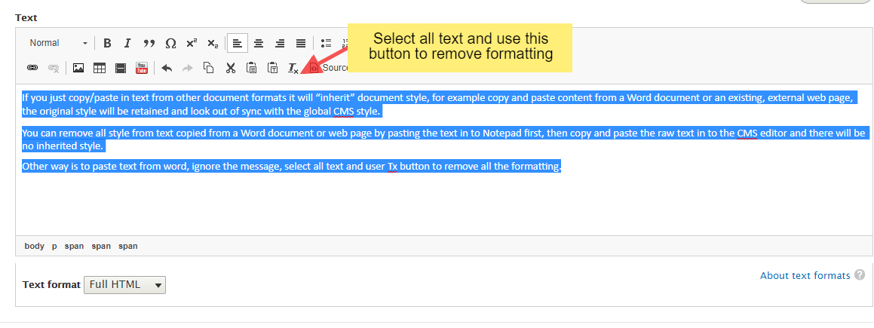  Proceed to style the text using the available options in the CMS editor.
Adding hyperlinks | Select words or a phrase you would like to use as a hyperlink.  Note: Don't use "click here" as a link text if you can avoid it. When calling the user to action, use brief but meaningful link text that:  - provides some information when read out of context  - explains what the link offers  - is not a verb phrase  Click on the link icon (first icon on the left)  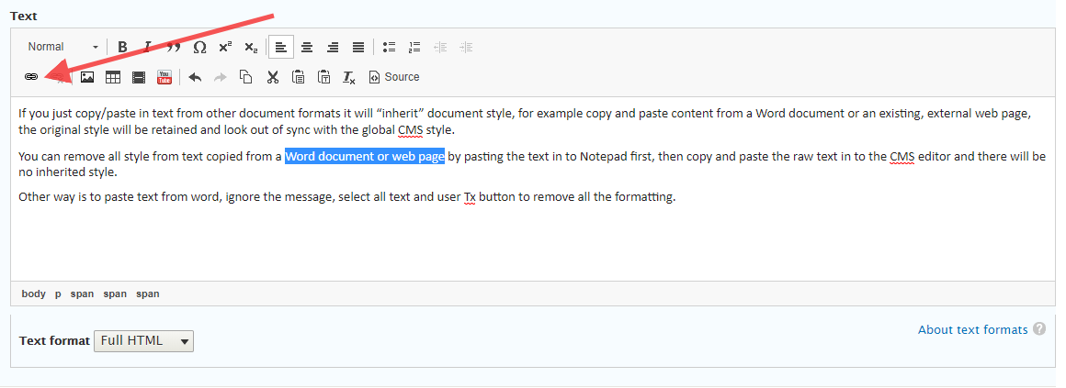  A dialog box opens as per below  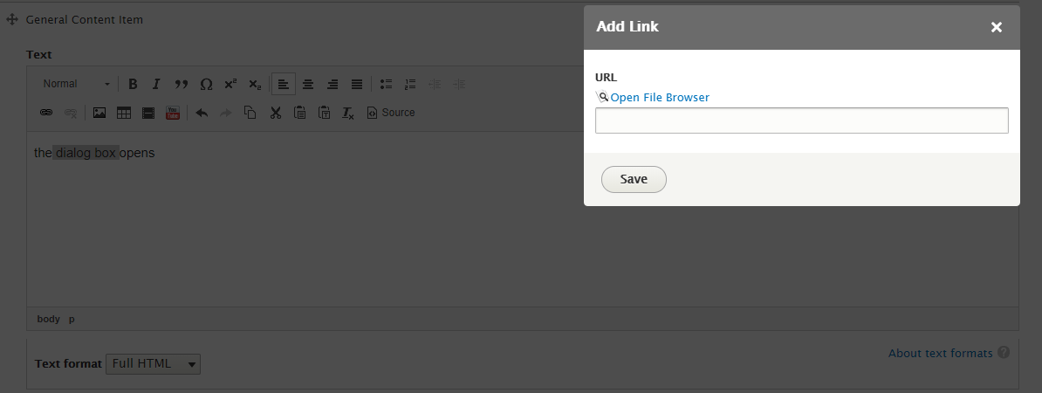  If you know URL or it is one to the external site – paste it into the box. Otherwise click on the words Open File Browser.
IMCE file management | Open File Browser link opens the IMCE File Manager  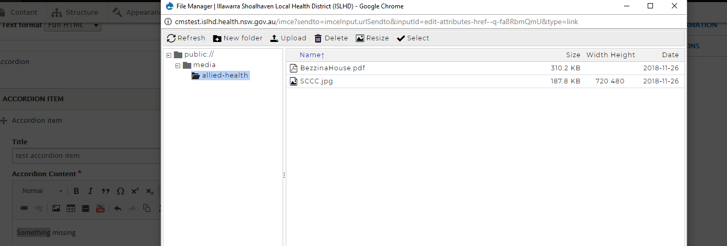  Select the folder for your Group e.g. Coledale Hospital before selecting or uploading a document.  - It is possible to upload your document to the wrong folder (another group) so be careful! You can create sub folders as you please to organise your content. Do this by clicking on the New folder option.  Use Upload then Add file to navigate to needed files on your PC or public folders. 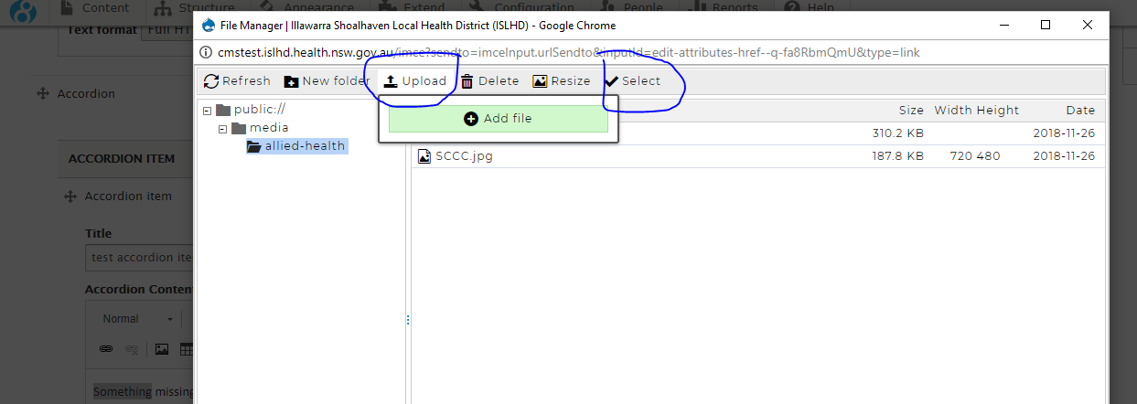Then make sure that you Select the file, then press Save to create a link.  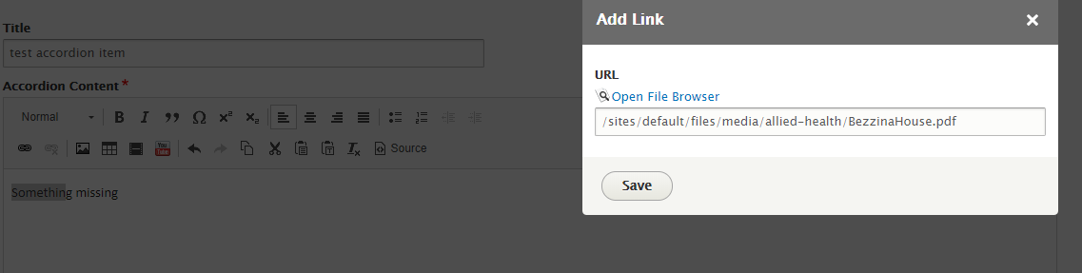
Adding images | The process similar to the above used to add inline images to the page.  The dialog box allows you to select alignment before you upload your image. Select your preferred alignment.  Note: left and right align will align big images using 50% of the available space. If you select a small image e.g. a logo – ti shouid take an actual image size None - will occupy all the window.  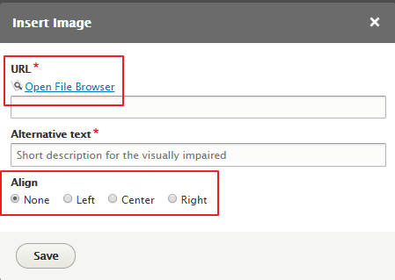  Next click Open File Browser and either select an image or upload an image as described above. You can also use Resize option to specify image size  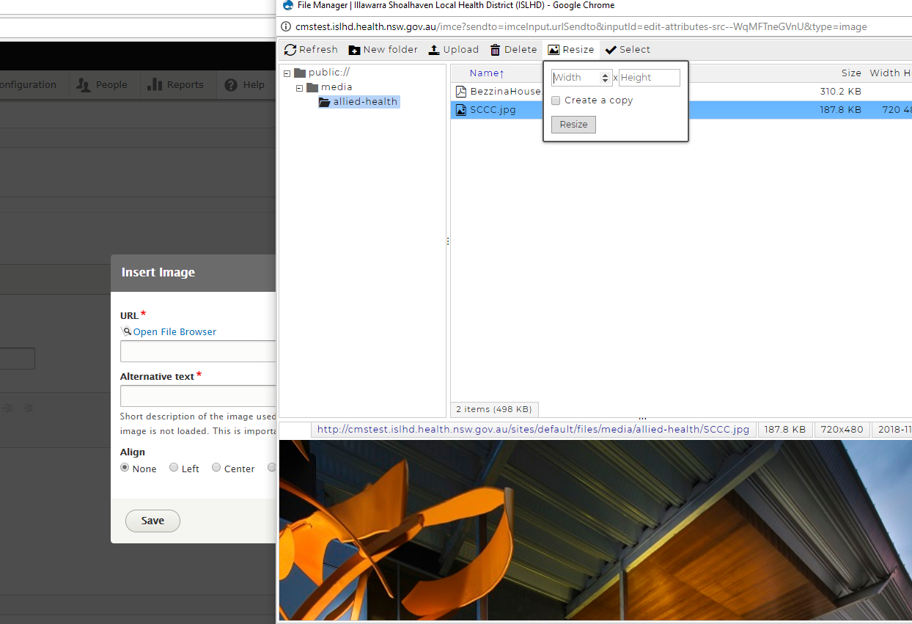  After uploading/selecting an image click Select. The next window should appear with the path to the image as below.  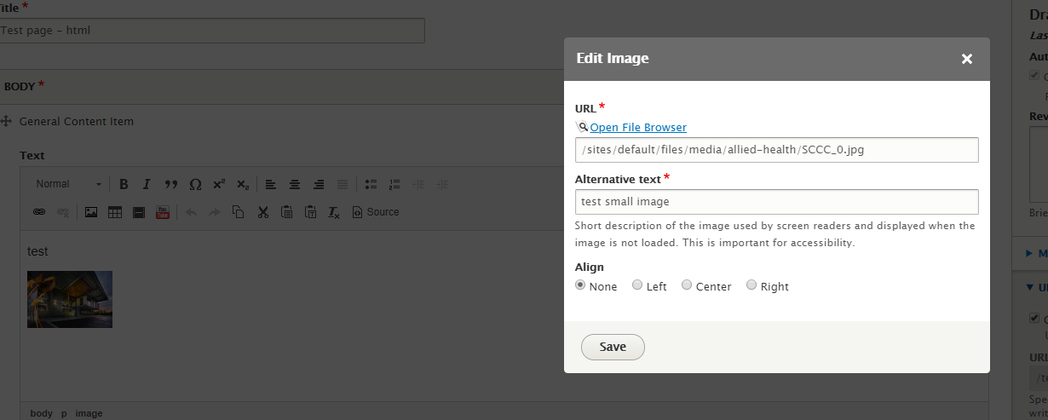  Select an alignment, press Save and Save the page.
Need help? | If your application is not working properly, you can submit an Incident Report through State Wide Service Desk at 1300 28 55 33 and specify it as ISLHD Internet issue  To learn more how to use the tool, contact <Web Team >
Document information
Owner
First published
Current version
Version change log

