Quick Reference Guide – ISLHD Internet
Content Management System
Logging in and basic site navigation
Objective: User can log in to ISLHD site, navigate to important areas of the site successfully, change password, log out, and log back in.
Action | Description
Pre-requisites | User account on the server with appropriate permissions
Notes and Precautions | User has used the single-use link in the system generated welcome email and set a password for their account.  We recommend you use either Chrome or IE11 for editing in Drupal
Logging in | Open a browser click on the staff login link on the top right corner http://cmstest.islhd.health.nsw.gov.au/
 | Alternatively navigate to the website's login page by adding /user/login at the end of the site URL (http://cmstest.islhd.health.nsw.gov.au/user/login )
 | You will be taken to the login page. Enter your CMS account credentials
Basic site navigation | If you have successfully logged in, you should see a black and grey toolbars at the top:  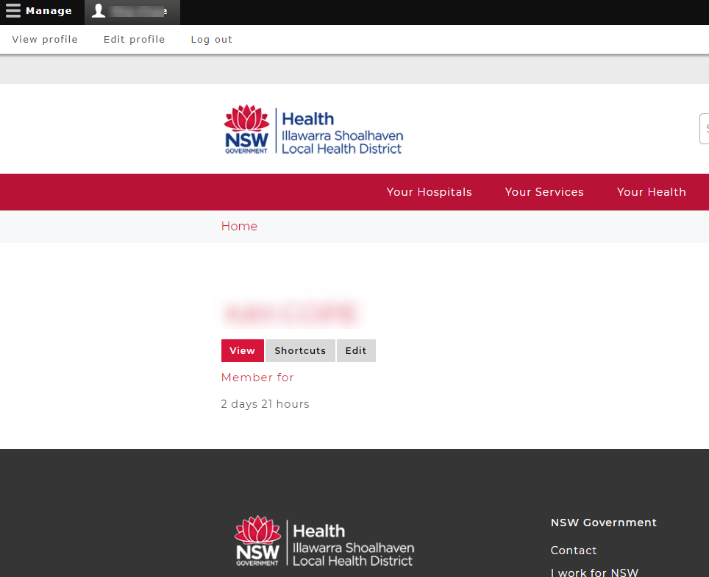
At the top of the page click on the link with your name – then you see View Profile, Edit Profile and Log out links, click the later if you would like to log out.
If you log out, you’ll be able to browse around the site as a visitor would but you will need to click the login link again to be able to create content or perform any other administrative task.
The top toolbar allows you to access the website's content:
If you click on the word Content, you will see all the pages of your site in a long list.
Use content filters to find a piece of content you are after.
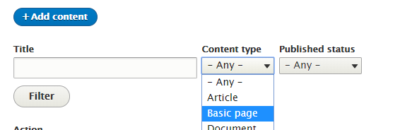
Understand grid headings
You have few ways to navigate to the site home page
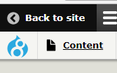
Then click on the logo or Home breadcrumb link
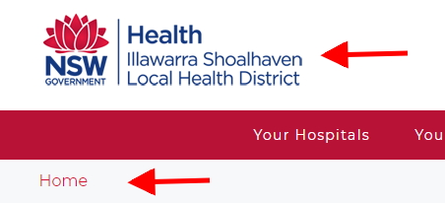
If you are one one of the hospital or Services pages click on the words Illawarra Shoalhaven Local Health District or Home breadcrumb link
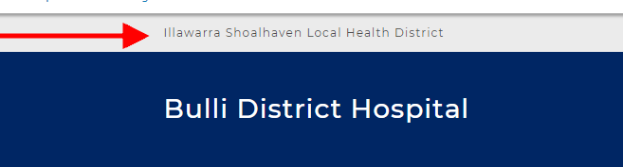
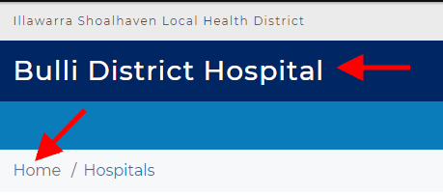

How to change your password | - Click on the link to reset your password  The email will be sent to you with instructions:  A request to reset the password for your account has been made.  You may now log in by clicking this link or copying and pasting it into your browser.  This link can only be used once to log in and will lead you to a page where you can set your password. It expires after one day and nothing will happen if it's not used.
- At the top of the page click on the link with your name – then you see View Profile, Edit Profile and Log out
You can view and edit your profile here, use the password field to reset your password.
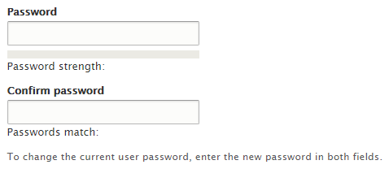
Scroll down to the bottom of the page and click on the Save button.
Need help? | If your application is not working properly, you can submit an Incident Report through State Wide Service Desk at 1300 28 55 33 and specify it as ISLHD Internet issue  To learn more how to use the tool, contact <Web Team >
Document information
Owner
First published
Current version
Version change log

